

**Western Australian Certificate of Education**

**ATAR course examination, 2017**

**Question/Answer Booklet**

12 PHYSICS

Name

**Test 7 – Atomic Physics**

|  |  |  |  |  |  |  |  |  |  |  |
| --- | --- | --- | --- | --- | --- | --- | --- | --- | --- | --- |
| Student Number: In figures |  |  |  |  |  |  |  |  |  |  |

**Mark: $\frac{}{\text{50}}$**  In words

#### Time allowed for this paper

Reading time before commencing work: five minutes

Working time for paper: sixty minutes

**Materials required/recommended for this paper**

To be provided by the supervisor

This Question/Answer Booklet

Formulae and Data Booklet

***To be provided by the candidate***

Standard items: pens, (blue/black preferred), pencils (including coloured), sharpener, correction fluid/tape, eraser, ruler, highlighters

Special items: non-programmable calculators satisfying the conditions set by the School Curriculum and Standards Authority for this course

**Important note to candidates**

No other items may be taken into the examination room. It is your responsibility to ensure that you do not have any unauthorised notes or other items of a non-personal nature in the examination room. If you have any unauthorised material with you, hand it to the supervisor before reading any further.

**Structure of this paper**

|  |  |  |  |  |  |
| --- | --- | --- | --- | --- | --- |
| Section | Number of questions available | Number of questions to be answered | Suggested working time  (minutes) | Marks available | Percentage of exam |
| Section One:  Short Answers | - | - | - | - | - |
| Section Two:  Problem-solving | 8 | 8 | 60 | 50 | 100 |
| Section Three:  Comprehension | - | - | - | - | - |
|  |  |  |  | **Total** | 100 |

**Instructions to candidates**

1. The rules for the conduct of examinations at Holy Cross College are detailed in the College Examination Policy*.* Sitting this examination implies that you agree to abide by these rules.

2. Write your answers in this Question/Answer Booklet.

3. Working or reasoning should be clearly shown when calculating or estimating answers.

4. You must be careful to confine your responses to the specific questions asked and to follow any instructions that are specific to a particular question.

5. Spare pages are included at the end of this booklet. They can be used for planning your

responses and/or as additional space if required to continue an answer.

• Planning: If you use the spare pages for planning, indicate this clearly at the top of the page.

• Continuing an answer: If you need to use the space to continue an answer, indicate in the original answer space where the answer is continued, i.e. give the page number. Fill in the number of the question(s) that you are continuing to answer at the top of the page.

6. Answers to questions involving calculations should be ***evaluated and given in decimal***

***form*.** It is suggested that you quote all answers to ***three significant figures***, with the

exception of questions for which estimates are required. Despite an incorrect final result, credit may be obtained for method and working, providing these are ***clearly and legibly set out***.

7. Questions containing the instruction "estimate" may give insufficient numerical data for their solution. Students should provide appropriate figures to enable an approximate solution to be obtained. Give final answers to a maximum of two significant figures and include appropriate units where applicable.

8. Note that when an answer is a vector quantity, it must be given with magnitude and direction.

9. In all calculations, units must be consistent throughout your working.

1. The photoelectric effect experiment supports the particle model of light rather than the wave model of light. The following are observed in a photoelectric effect experiment.

**Observation 1:** The number of emitted electrons (the photocurrent) depends on the intensity of the incident light.

**Observation 2:** The energy of emitted electrons depends only on the frequency of the incident light and is independent of the intensity.

**Observation 3:** The energy of the emitted electrons depends on the metal surface involved.

The particle model can account for all the above three observations. The wave model can explain two of these observations but not a third.

(a) Select the observation that the ***wave model cannot explain***.  (1 mark)

Observation number

(b) Explain how the ***particle model*** satisfactorily explains this observation. (2 marks)

2. Students set up the following apparatus as shown in Figure 2 to study the photoelectric effect. They have a number of photocells with different metal plates in them.

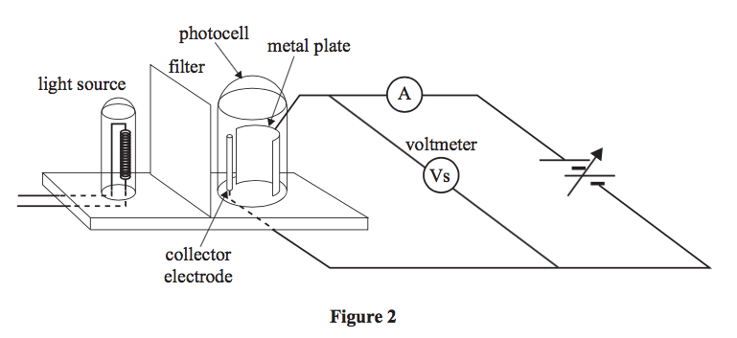

With a selenium plate in place, and using their data, the students draw the graph of maximum kinetic energy of photoelectrons versus frequency of light incident on the selenium plate. This is shown in Figure 3.

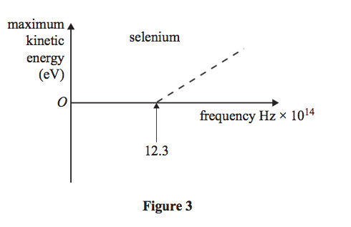

(a) The students double the intensity of the light source and repeat the experiment. Which one of the following graphs will now show their results? (Circle your answer.) (2 marks)

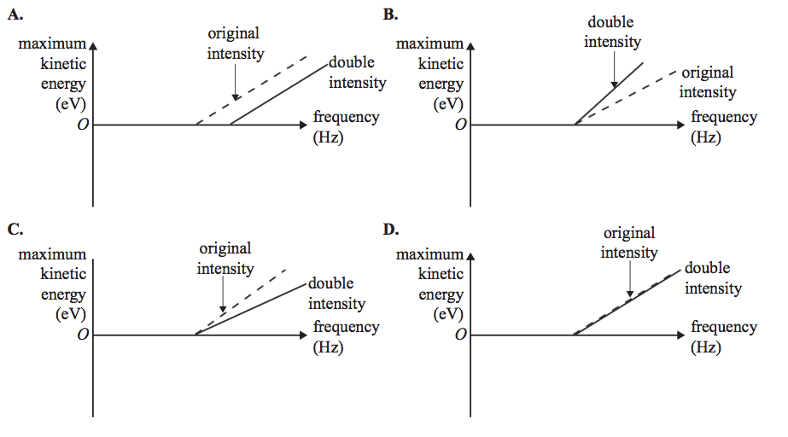

(b) The students now use a photocell with a magnesium plate. The work function of magnesium (3.7 eV) metal is less than that of selenium (5.1 eV).

***The dotted line on each graph shows the original graph for selenium.***

(i) Which one of the following graphs will now show their results? (Circle your answer.) (1 mark)

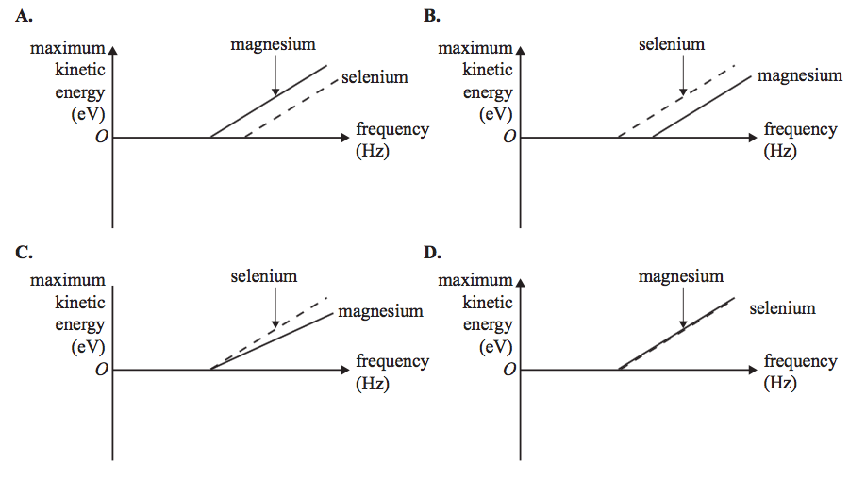

(ii) Explain your answer. (2 marks)

3. Sodium metal has a work function of 2.30 eV.

(a) What is the wavelength of light that will just eject an electron from a sodium surface?

(3 marks)

(b) Light of wavelength 122 nm is incident on a sodium photocell.

(i)   Calculate the maximum energy (in eV) of the emitted photoelectrons?

(4 marks)

(ii)   Determine the maximum speed of the emitted photoelectrons? (3 marks)

(iii) What is the cut-off (stopping) voltage of the photocell? (3 marks)

4. A group of students were investigating the dispersion of light from a 1.30 mW red laser operating at 580 nm. If the laser is used for 35.0 s, calculate the number of photons transferred to the slits. (4 marks)

5. A gas sample has the following energy levels in its atoms.

- 1.30 eV

0.00 eV

- 3.10 eV

- 5.90 eV

- 11.70 eV

It is contained in a glass tube under normal pressure and bombarded with 8.80 eV electrons.

(a) On the diagram above, indicate the maximum upward transition of electrons possible from the ground state.

(1 mark)

(b) How many emission photons can be produced from this transition? Show these on the diagram. (2 marks)

(c) Calculate the ***largest possible wavelength*** produced by these photons. (4 marks)

6. Some substances will ***fluoresce*** by photon absorption, while others will ***phosphoresce***.

(a) Explain how fluorescence occurs for an atom. ***Include a simple energy level diagram*** in your explanation. (3 marks)

(b) In terms of electron transition, how is phosphorescence different to fluorescence? (1 mark)

(c) "Optical whiteners" are added to laundry detergents to make fabric colours "brighter” and true in colour when viewed under sunlight. Explain how they achieve this. (2 marks)

7. Fraunhofer lines are used by astrophysicists to study the elemental structures of stars, finding they are mainly composed of hydrogen gas. They appear as dark lines on a continuous colour spectrum.

(a) What type of spectra is this? (1 mark)

(b) Explain how Fraunhofer lines are formed. (2 marks)

8. The diagram below shows the basic components of a stationary anode X-ray tube.

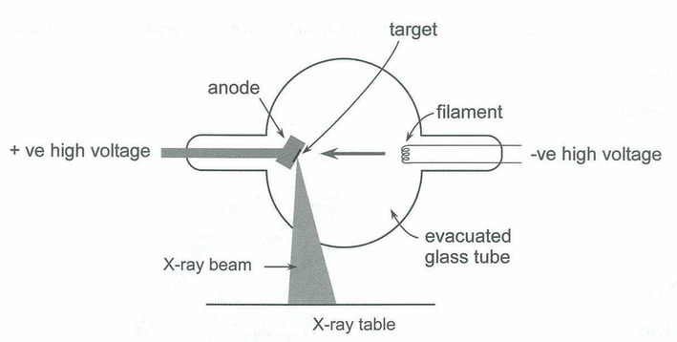

(a) Describe how X-rays are produced in the tube. (4 marks)

(b) The spectrum produced by the X-ray tube consists of two features. With reference to the diagram below, explain the shape of the X-ray spectrum produced. (4 marks)

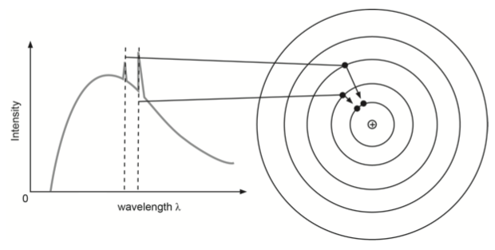

(c) Electrons are accelerated by a potential difference of 14.8 keV in the X-ray tube. Determine the minimum wavelength of the X-rays produced. (4 marks)